The Unreasonable Effectiveness of Mathematics on Philosophy

This is a Wigner-like math and philosophy inter-analysis. It is not about writer's block for me, but exploring a meta-analysis of writers' block and identity. Writer's block isn't always a thing, when one's identity is not defined by being a writer, at all times. If one is not compelled to identify as a writer, writing only when interested suggests that writer's block is more of an interest block. This excludes obligatory writing assignments, for work and such, where the need to write is moreso linked to the occupation, than the being. In Sartre's Being and Nothingness, this is described in the waiter analogy:

“As bad faith, Sartre describes one's self-deception about the human reality. It can take two forms, the first one is making oneself falsely believe not to be what one actually is. The second one is conceiving oneself as an object (e.g. being identical to a job) and thereby denying freedom.[7]
This essentially means that in being a waiter, grocer, etc., one must believe that their social role is equivalent to their human existence. Living a life defined by one's occupation, social, racial, or economic class, is the very essence of "bad faith", the condition in which people cannot transcend their situations in order to realize what they must be (human) and what they are not (waiter, grocer, etc.). It is also essential for an existent to understand that negation allows the self to enter what Sartre calls the "great human stream". The great human stream arises from a singular realization that nothingness is a state of mind in which we can become anything, in reference to our situation, that we desire.
The difference between existence and identity projection remains at the heart of human subjects who are swept up by their own condition, their "bad faith". An example of projection that Sartre uses is the café waiter who performs the duties, traditions, functions, and expectations of a café waiter:
[W]hat are we then if we have the constant obligation to make ourselves what we are if our mode of being is having the obligation to be what we are? Let us consider this waiter in the café. His movement is quick and forward, a little too precise, a little too rapid. He bends forward a little too eagerly; his voice, his eyes express an interest a little too solicitous for the order of the customer. Finally there he returns, trying to imitate in his walk the inflexible stiffness of some kind of automaton while carrying his tray with the recklessness of a tight-rope-walker by putting it in a perpetually unstable, perpetually broken equilibrium which he perpetually re-establishes by a light movement of the arm and hand. All his behavior seems to us a game. He applies himself to changing his movements as if they were mechanisms, the one regulating the other; his gestures and even his voice seems to be mechanisms; he gives himself the quickness and pitiless rapidity of things. He is playing, he is amusing himself. But what is he playing? We need not watch long before we can explain it: he is playing at being a waiter in a café. There is nothing there to surprise us.”

So, replacing waiter with writer, one can ask themselves, “am I not writing because my thoughts are not in writing at this time, or because I am not a writer at this time?” The difference is that essence (being) is defined as an instantaneous activity, rather than a status for a fixed, (usually longer) interval (e.g. 6AM to 2PM), or evening shift (2PM- 10PM).

Sartre was trained in classical mathematics at a young age:

“Anne-Marie moved back to her parents' house in Meudon, where she raised Sartre with help from her father Charles Schweitzer, a teacher of German who taught Sartre mathematics and introduced him to classical literature at a very early age.[8] “

[8] Brabazon, James (1975). Albert Schweitzer: A Biography. Putnam. p. 28.
Thus he might not be unfamiliar with differential equations. I understood differential equations more at age 17, in my senior year of high school, than I do now. But I still remember the concepts, and the points on a slope, which can be written as a f(x)= dx/dy.

Imagine, that a curve in a function has multiple points of interest to an employer. The employer believes the waiter is slacking on the job. Now, imagine, a third axis, z, is checking the status of the value of each interval.
Or imagine that third axis is you, looking down on the x-y axis.

Determining the value at various points on the curve is to crucial to whether this curve is a function at all points. If it is not a function, then the employed person in the role of a waiter is not a waiter in terms of his identity. If you dislike or disagree with Sartre, you must first determine whether this slope is continuous or discontinuous. If you can find that every point on the curve is continuous, then that means the waiter has been determined to have been 100% productive at all hours of his shift. If he has been idle during a time where he was supposed to be working, that is curve is considered “not a function.”

https://en.wikipedia.org/wiki/Continuous_function#Real_functions

“A real function that is a function from real numbers to real numbers can be represented by a graph in the Cartesian plane; such a function is continuous if, roughly speaking, the graph is a single unbroken curve whose domain is the entire real line. A more mathematically rigorous definition is given below.[8]”
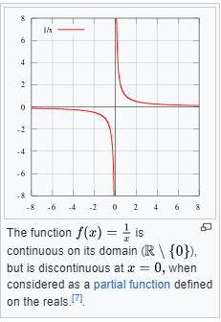
Consider a waiter who works two “jobs:” one during the day and a one (paid or unpaid) at night. For example, in an off-Broadway play, or a comedy show, that “waiter” would not identify as a “waiter” at night -”off shift”- because they may identify as an actor, seeking to become famous, or develop a new identity. Thus, writer's block is not necessarily due to an inability to write creatively, but to time limitations in transcribing thoughts to paper or a digital medium.
Imagine the waiter is working from -8 to -0.25 (7.75 hrs), but is not very productive in the last few minutes of the end of their shift, because they are not serving customers but closing the register or store. Technically and legally it is still considered work, but is not an income-generating task (accepting cash/credit from customers). At point zero, they are clearly not working. 0 is an infinitely small value, and would not be analogous to the time one clocks out or in to work, nor to the sleep one needs to work each day. While 0 is a value, it is not a null value. This can be somewhat analogous to Sartre's concept of non-negation of nothingness:

“Zero (0) values
Zero (0) is a number. It is a measurement that shows that something "is not," did not occur, or occurred below a measurable level. A zero is not the same as a missing (was not observed) or invalid value. The only way zero should be encoded is with the '0' character as this ensures that it will be processed as a number.

Null values
Unlike zero, null values are not an absolute or something quantifiable; they're an unknown. As such they should not be stored as numbers (i.e. 0, -999, 999, etc.). The table below provides information on the best and worst ways to encode null values in a dataset.”
Source: https://instr.iastate.libguides.com/spreadsheets/zero#
The analogy of identity to a waiter on shift is easier to conceptualize identity vs. non-identity, but in reality, most people still identify with their occupation even when they are off-shift.
Sartre's concept of being in-itself is like day dreaming during the job when the waiter is not productive, but no discernible activity outwards shows that he is not working. For example, if he is standing near a table of patrons who have already been served food, his main role is to determine if they are calling for him (e.g. refills, a missing utensil, a condiment, ordering dessert, “check please!”). The owner/manager, if not the same as the waiter, might see the waiter in a sufficiently alert pose/composure, but the waiter may be daydreaming and actually not see a silent handwave by the seated guests. If the owner only has a view of the waiter and if the guests do not alert the owner that the waiter was inattentive, they have discretely created an event that allows the waiter to have succeeded in showing no record of unproductiveness in their Yelp review, if they overlook his initial inattentiveness due to a finer service later in the dining experience. He may say, “Oh sorry, I did not see you there” and rush to help them with their request. He may also overcompensate for his service, or show some other hospitality that causes the patrons to leave raving reviews, leading the owner to believe that the waiter was 100% productive during his shift, and was never daydreaming while assisting the patrons.
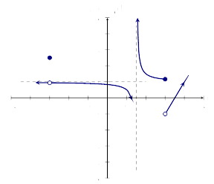
An occasionally daydreaming waiter at discontinuous points.
Source:https://ximera.osu.edu/csccmathematics/precalculus1/precalculus1/graphicalAnalysis/discontinuities-figure0.svg
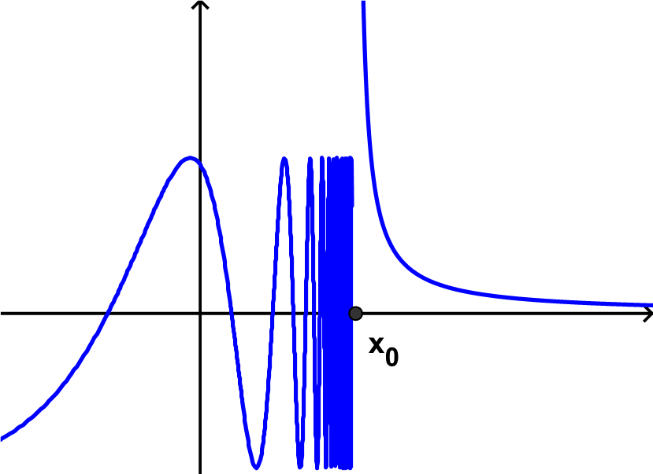
A seriously slacking employee, or is he? This is actually discontinuous at only one point, x_{0.} Is it a function?

In the next example, the waiter is not considered a function, because there are a multiple values at several points that do not pass the vertical line test. It is analogous to the owner noticing the waiter daydreaming while the customers are waving at him. A silver lining of this is that that day dreaming can actually solve the comedy actor's writer's block!
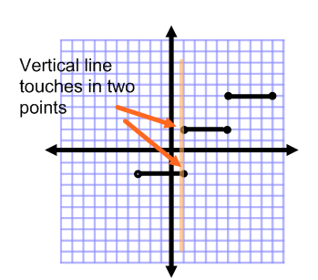
“This graph is not a function because when utilizing the vertical line test, it touches in two points. “
Source: https://www.algebra-class.com/step-functions.html
The scope of this paper has only analyzed a few types of discontinuous functions and non-functions. An extreme example of discontinuous function is the everywhere discontinuous function:
“Thomae mentioned it as an example for an integrable function with infinitely many discontinuities in an early textbook on Riemann's notion of integration.[4] “ Source: https://en.wikipedia.org/wiki/Thomae%27s_function
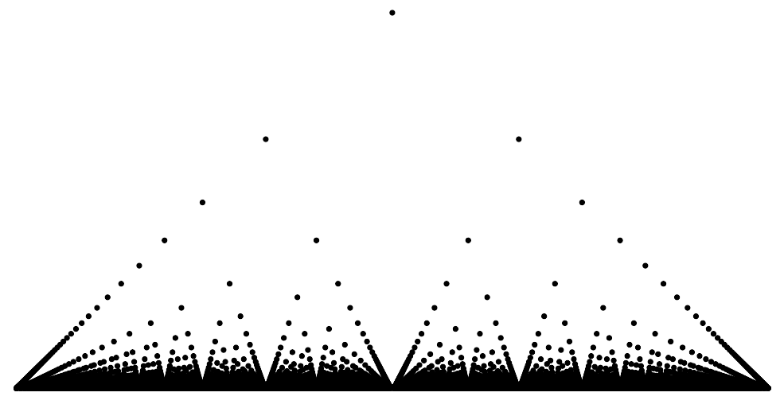
An everywhere discontinuous function. A functional scatterbrain?
Conclusion
Writer's block is largely an obstacle created by the impression that identity is being-in-itself. Sartre believed that a waiter is:
“primarily a man (being-for-itself), just one who happens to be functioning as a waiter – with no fixed nature or essence, who is constantly recreating himself.”
A writer who is able to break free from the belief that his being is at his core, a writer, can break writer's block. He may also discover how to be a better waiter during his night shift.
-Giovanni Lostumbo, May 2024

